Week 3 Reading and Assignments
Complete the following reading early in the week:
- Week 3 online lectures
- From your textbook, Exploring Digital Cinematography, read the following chapters:
  - The Virtual Camera
  - Introduction to Light and Color
- Review the text 3ds Max 2010 Bible, by Kelly L. Murdock, as needed to reinforce and expand on the concepts and techniques required for this week’s assignments.
Assignment Summary: Week 3 | Due Date
Assignment 1: Discussion Questions | Friday, May 28, 2010
Assignment 2: Continuity Editing | Saturday, May 29, 2010
Assignment 3: Cross-Dissolve | Sunday, May 30, 2010
Assignment 4: Final Project: Scene Planning—Phase II | Tuesday, June 1, 2010

Week 3 Overview
Welcome to Week 3. In the previous weeks, you have seen how to use a camera to develop a relationship between a scene and the viewer or player. We have often found ourselves laughing and shedding tears with the characters, experienced the pain and happiness, and felt the grip of horror or suspense around us—all created by the settings in a scene! Have you ever wondered how a developer or director makes his or her viewer react to the drama that is created? How does a director control the emotions and the reactions of viewers? Is it an art or just an acquired skill? How does a developer make sure the player can follow the narrative of a game given the freedoms of game play? This week, we will study the answers to all these questions.
Editing
As you discovered, camera placement and movement define a relationship between the subject in the frame and the viewer. But, as a developer or director, how do you connect with your viewers or players? Can you motivate your players to participate actively with you to bring forth the intentions in your scenes?
The answer to these questions lies in understanding one of the most important aspects of the game development process, or the moviemaking process—editing. On one hand, editing is the process of selecting the best frames and joining them together to create a final scene. On the other hand, editing, much like camera placement and movement, intensifies emotional responses in your players. It helps you establish a mood and the flow in a scene. Because of this, the flow of information is crucial to manipulate the emotions and viewpoint of your viewers and players. With skillful editing, you can also make them feel and respond to the narrative beyond passively participating in it
A successful developer or director is one who can make the viewer actively imagine, assume, deduce, and conclude the events of the storyline. This task is demanding and calls for an experienced eye and a lively imagination. This week, we explore the various dimensions of editing and understand how it empowers you to make your viewers and players active participants in the story events rather than being passive spectators.

Learning Outcomes
Know how to employ cuts, pans, overlap and matching action, pictorial and directional continuity, and depth of field.
The Power of Editing
For films, you can use the art of editing to establish a relationship with your viewer; through effective editing, you can orchestrate what the viewer should know and when he or she should know it.
For games, editing takes a back seat in creating a relationship with the player because a majority of the player’s relationship to the story comes from the avatar. The power of editing in games relates to the storyboard, ensuring the narrative of the game doesn’t get lost in the need to complete objectives.
For now, we’ll take a look at editing for film and we’ll discuss editing in games in a little bit. Let's visualize two frames. In Frame 1, a woman is walking towards the camera and in Frame 2, the woman is lying unconscious.
When seen in this order, we assume that the woman has tripped and fallen. Where does this assumption come from? What made us think that the woman has tripped?
The human brain has the undeniable ability to relate prior experiences with visuals and draw conclusions. When faced with the question, "What happened to the woman?" unconsciously, our brain looked for evidences to find an answer. And what evidences do we have? Looking at the second frame in which the woman is lying unconscious, we conclude from our prior experience that people who trip and fall end up on the ground! In this situation, the two shots filled the gaps and created a logical closure of the sequence.
The director presented a sequence, and the viewer reached a conclusion. The director successfully prompted the viewer to do something more than just watch. The viewer was invited to become an active participant in the visual story process, and the viewer was motivated enough to expend the effort. With careful sequencing of the frames, the director successfully established a relationship with the viewer.
As the saying goes, movies are made or ruined in the editing room! With well-planned and thoughtful editing, a talented director can stitch together a few short scenes and present an excellent feature. However, excellent performances can be marred if the movie is poorly edited.
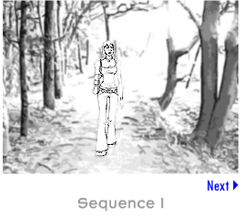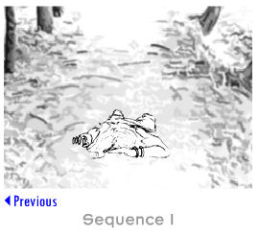
Continuity Editing
In the previous lecture, you learned how editing places power in the hands of a director and helps develop a relationship between the director and the viewer. Let's now learn how we can stimulate the imagination of our viewer to fill in the gaps and contribute to the development of a story.
Let's add another frame to our previous sequence: The third frame shows a mischievous looking kid leaning against a tree and eating a banana. Several banana peels are seen scattered on the ground.
Therefore, we have three frames now:
- A woman is walking toward the camera.
- The woman is lying unconscious.
- A mischievous-looking kid is leaning against a tree. The kid is eating a banana, and several banana peels are scattered on the ground.
Adding the third frame changes our answer to the question, "What happened to the woman?" The director has now provided a different clue to formulate our answer; thereby, changing the interaction between the viewer and the scene. The sequence is now more complex and presents new possibilities to us. Our brains are now trying to find answers for a new set of questions: "Who is the mischievous looking kid?" "Did the woman slip on the banana peel that the kid threw deliberately?" and "Is the woman badly hurt?" In this case, the director has changed the relationship of the viewer with the scene by creating a more complex interaction that requires more questions to be answered. The viewer then demands more frames to provide the missing information until the climax of the film finally offers the answer to almost all the questions that a viewer can ask during the course of the film.
Although we did not actually see the action between the frames, we are able to draw a logical conclusion from the previous sequence. This blank area between the frames is where the director develops a relationship between his intentions and the viewers' emotional reactions.
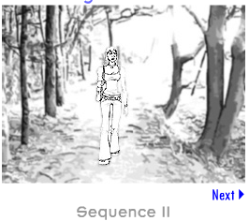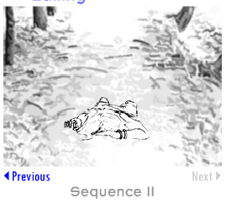
Changing the Expected Continuity Editing
Up to this point, we have the three frames in the sequence:
- A woman is walking toward the camera.
- The woman is lying unconscious.
- A mischievous-looking kid is leaning against a tree. The kid is eating a banana, and several banana peels are scattered on the ground.
This sequence is effective in answering the very basic question: "What happened to the woman?" Now, let's take a closer look at the role that the frame arrangement plays in changing a viewer's emotional response to a scene.
Visualize a sequence in the following order of frames:
- A mischievous-looking kid is leaning against a tree. The kid is eating a banana, and several banana peels are scattered on the ground.
- A woman is walking toward the camera.
- The woman is lying unconscious.
What emotional impact does this sequence have on the reaction of the viewer?
By placing the frame of the kid first, we are informing the viewer that the woman is in danger before the result of that danger is actually portrayed on the screen. So, when we watch Frame 1 of the woman walking, which is now second in the sequence, we feel suspense or impending doom. This sequence has an entirely different emotional impact on the viewer.
As a director, you can decide the sequence of the frames and change the impact of a scene dramatically. With well-planned editing, you dictate the viewer's emotional reaction to the scene.
Time Perspective:
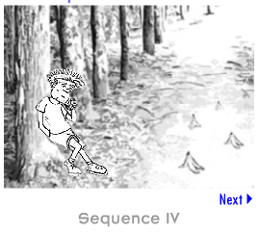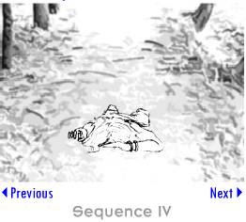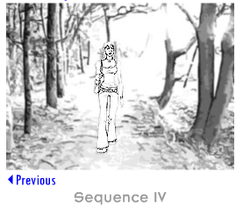
The Time Perspective
With editing, you can help the viewer imagine or deduce all the action while not actually showing it on the screen. With intelligent sequencing, you can create blank areas between frames that cause your viewers to draw the desired conclusion about unseen events and even stimulate them to experience the time perspective of an event. For example, if we again change the order of the frames in the sequence to:
- A mischievous-looking kid is leaning against a tree. The kid is eating a banana, and several banana peels are scattered on the ground.
- A woman is lying unconscious.
- A woman is walking toward the camera.
What logical conclusion can a viewer draw from this order of the sequence?
The woman has already been shown sprawled, and now she is being shown walking around. The viewer will likely reach a logical conclusion that the frame, which shows the woman walking, is from the past as it is unlikely that the woman would start walking normally after being hurt from a nasty fall. It seems so simple and is something the viewer didn't actually see. With thoughtful editing, the director created a blank area between the frames where all the action happened. This blank area helped the director to develop a relationship with viewers and elicit the desired emotional reaction from them.
Now let’s look at editing in games.
One thing that is crucial to keep in mind is that a game editor can only manipulate what he or she controls. For the most part, that means the storyline or narrative, the spawning of characters, the objectives, and the environment. It might seem like a lot, but you’ll notice there is no control over the player’s avatar itself. For example, in a film, the director has complete control over what way in which a character will walk, or how a character will respond to a situation. In a game, all these factors are up in the air because of the control that is given to a player through game play. Granted, there are a finite number of options for a player, but even still, editing in a game does not occur on a macro level as in a film. Editing cannot take place on the level of frames in a game, because there are no cuts in games. It can only take place between sequences.
Think of editing for games as more closely linked to the layout of a storyboard then to individual cuts or frames. How the player will move through an environment, what objectives will need to be set up in order for the player to progress in a way that will advance the story, and how the player will gain enough information through these sequences to be able to accomplish the next objective are all critical aspects of editing in games. They keep the player moving forward through the story and emotionally tied to the avatar. If a player is not guided through objectives to the forest where the secret key is hidden, he will get to the castle and not be able to open the gates for his forces that wait to overthrow the king.
Editing is a powerful art that is often seen as nothing more than a means to put frames together into a longer sequence or film. However, as you just learned, it’s truly a way to get the audience actively involved with the experience of watching a film or playing a game.
Transitioning Techniques
The previous lectures introduced you to the dimensions and scope of editing. We also looked at how images are carefully selected and logically arranged to create a scene. As a developer or director, you also need to plan how a frame best transitions to the next in a movie, animation, or cut scene to maintain a logical continuity and bring out the desired effect in the scene.
It is most important that the transition between the frames is smooth and logical. For example, placing a frame with a woman driving a car after showing a man talking on the phone would possibly not make much sense to a viewer and may even look erroneous. For the radical blending of these two scenes, it is important to place at least one connecting frame between them—a frame with the woman talking over the phone, before showing her driving.
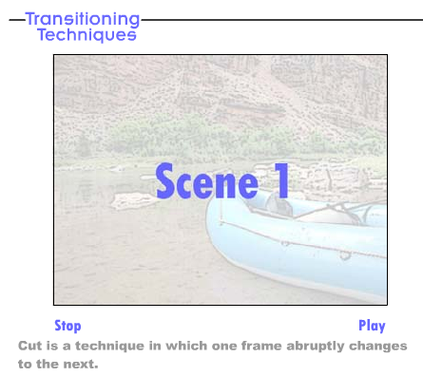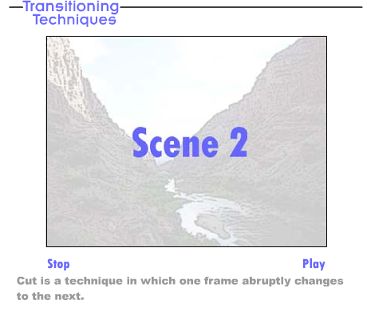

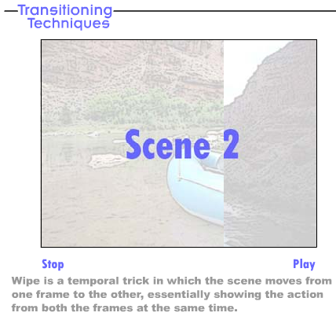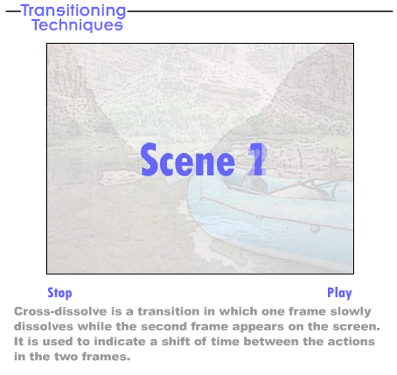
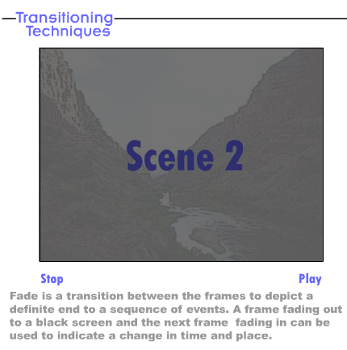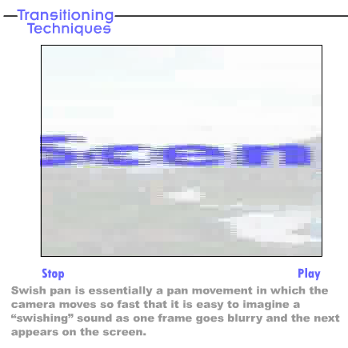
Bringing it All Together
Now that we've discussed the methods to transition between frames, you can use some of these techniques to see how they affect a scene. Let's go back to our three frames:
- A woman is walking toward the camera.
- A woman is lying unconscious.
- A mischievous-looking kid is leaning against a tree. The kid is eating a banana, and several banana peels are scattered on the ground.
Let's open with the frame of the woman who is walking briskly towards the camera. The frame shows a slow wipe that transitions into a frame of the kid leaning against a tree and eating a banana. The wipe stops midframe and becomes a split screen that shows the woman and the kid eating a banana. From there, the wipe completes and ends on the kid. The kid has a mischievous look on his face and is intently tracking the woman's movement. The frame of the kid cross-dissolves to the walking woman and holds. Simultaneously, the audience hears a loud thud and a sudden cut back to the kid. The swish pan shows the frame of the kid to the frame of the woman sprawled on the road. From there, the scene fades to black.
Now, think about all the effects we added to a relatively simple scene by using well-planned transitions and good editing. We added suspense by showing the walking woman and the kid at the same time. We lengthened the time of the suspenseful moment through the cross-dissolve from the kid to the woman. The abrupt nature of the cut and the added sound successfully depict the walking woman slipping on the banana peel. With the use of the swish pan in the scene, we effectively depicted that the woman ran a long distance before she slipped. And, finally, the scene fades into darkness to mark the end of the scene.
See video – bringing it all together
Summary
A scene is created with the combined efforts of a director, screenwriter, characters, lighting designers, sound designers, cameramen, and other technicians. However, before a scene is finally presented to viewers, it goes through a complete transformation in the editing room. The director reviews the unedited film and usually spends hours to plan the sequence of frames and transition of the scenes. This process is arduous and may take as long as a month before the scene is finally put up for viewing. Another useful technique that is employed is the Top Down Diagram.
Top Down Diagram
A top down diagram allows a developer to look at the scene's environment as a whole and map out the camera's movements through a scene. It also allows the developer to look at the negative space between character movement, objects in the scene, and the camera itself. For example, if we have a bedroom in which there is a nightstand, a bed and a standing lamp, we can look from above the scene and ensure that the characters will be moving around these objects with ample space for the camera to follow or navigate with the character's movements.
This type of diagram also allows a developer to rearrange objects to create the optimal movement for a player's advancement through the scene. Many times while in beta testing developers will look at how players move through an environment and make sure there aren't places in which the player is continually becoming lost or misguided by objects in the scene. A good example of this are maps for games like Halo or Call of Duty. Logging into Bungie's website, a player of Halo can see a top-down diagram of a map they have played on and can visualize the areas in which they progressed through the story, died the most, or had the most kills. In this way, the player can perfect their movements from one area of the map to another.
Scenes may have been photographed poorly and performances might have been less than inspiring, but with powerful editing, a skilled and creative director can assemble the film so that the audience never notices these imperfections. Thoughtful and well-planned editing can help you achieve the mood and emotional intent of the scene. Directors often experiment with editing techniques to bring out the desired effects in their scenes. So when you next watch a movie, pay close attention to observe how the director successfully engages your mind with the judicious use of editing techniques.
Assignment 2: Continuity Editing
Take any three frames of a scene that you've created previously and place them in different orders to achieve at least two different story effects. Make a note of how the meaning of the scene is changed as you change the sequence of the frames.
Save your animation following this sample naming convention: Sequence_number_First name. Submit your assignment as a ZIP file.
By Saturday, May 29, 2010, post the rendered scenes in the W3: Assignment 2 Doc Sharing folder, and post your observations to this Discussion Area. Review and critique the work of at least two other students early in the week and comment on the way they have used various effects to convey depth and mood. Then revise your work based on the peer reviews you have received.
Assignment 2 Grading Criteria | Maximum Points
Created at least two different story effects with any three scenes from the previous work. (2 x 6 points for each story effect) | 12
Observed the effect of the placement of scenes to achieve a desired intent of the sequence. (2 x 6 points for achieving the desired intent) | 12
Displayed an understanding of the use of editing as a tool to depict emotions. | 8
Actively participated in the Discussion Area. | 4
Total: | 36
For assistance with any problems you may have when completing this assignment—OR—to offer your assistance to classmates, please use theProblems and Solutions Discussion area located through the left side navigation link.
ProTip
Please post your files here to the DISCUSSION BOARD
Assignment 3: Cross-Dissolve
Take one of the sequences that you created in the previous assignment: W3: Assignment 2. Place a cross-dissolve between two of the frames to see how this effects time. Try other effects, such as a wipe on the other sequence.
Save your animations following this sample naming convention: Cross-dissolve_First name and Wipe_First name.
Submit your assignment as a ZIP file.
By Sunday, May 30, 2010, post your ZIP file in the W3: Assignment 3 Doc Sharing folder and your observations to this Discussion Area. Review and critique the work of at least two other students early in the week. Provide a critique to encourage them to deepen their thinking about the concepts. Then, revise your work based on your peers' feedback.
Assignment 3 Grading Criteria | Maximum Points
Illustrated different transitions, such as cross-dissolve and wipe between the two scenes taken from the previous assignment. | 12
Observed the transformation with time perception when transitions are changed. | 12
Actively participated in the discussion and provided constructive comments about the responses posted by other participants. | 8
Total: | 32
For assistance with any problems you may have when completing this assignment—OR—to offer your assistance to classmates, please use theProblems and Solutions Discussion area located through the left side navigation link.
Pro Tip
Please post your files here to the DISCUSSION BOARD
Assignment 4: Final Project: Scene Planning—Phase II
In W2: Assignment 3, you created a simple storyboard panel and a description of the emotional intent of the scene of your choice. Based on the storyboard and the intent of your scene, prepare a top-down diagram of this scene. This diagram can be a simple screen capture from the top view.
Save your diagram following this sample naming convention: Top-down diagram_First name.
By Tuesday, June 1, 2010, post your top-down diagram to this Discussion Area. Review and critique the work of at least two other students as early as possible. Provide a critique so that you encourage them to deepen their thinking about the concepts. Then, revise your work based on the peer reviews that you receive. After incorporating the changes post your revision, inviting the reviewers to comment on your changes by the end of the week.
Assignment 4 Grading Criteria | Maximum Points
Created a top-down diagram of the scene. | 12
Accurately described the emotional intent of the scene. | 4
Actively participated in the discussion and provided constructive comments on responses that other participants posted. | 4
Total: | 20
For assistance with any problems you may have when completing this assignment—OR—to offer your assistance to classmates, please use theProblems and Solutions Discussion area located through the left side navigation link.
Pro Tip
Please post your files here to the DISCUSSION BOARD

